Angular 2 vs AngularJs

* Angular 2 is entirely component based. Controllers and $scope are no longer used
* **TypeScript = ES6 + Types + Annotations**
* Angular 1.x was made for responsive and two way binding app. There was no mobile support.
* ngular 1 core concept was **$scope**, and you will not find **$scope** in angular 2.0. Angular 2 is using **zone.js** to detect changes
* 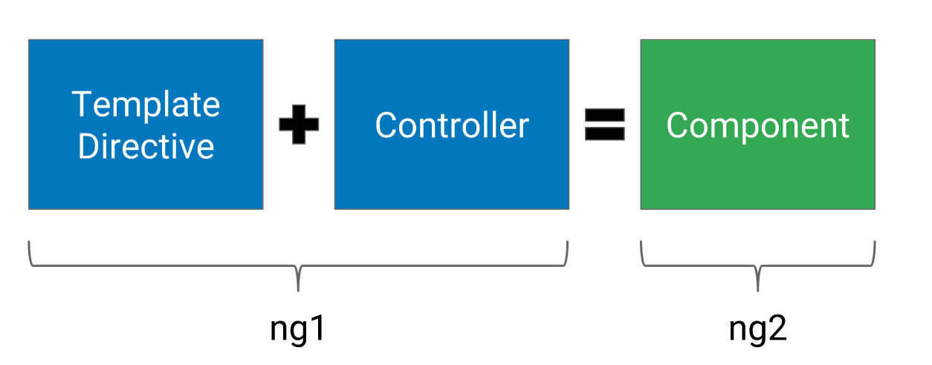
* Angular 2 is **using Hierarchical Dependency Injection system** which is major performance booster. Angular 2 implements unidirectional tree based change detection which again increases performance . As per ng-conf meetup, **angular 2 is 5 times faster**as compared to angular 1.
* Remove the Need for Many Directives
* With [ultra fast change detection](https://docs.google.com/document/d/1QKTbyVNPyRW-otJJVauON4TFMHpl0zNBPkJcTcfPJWg/edit) and  immutable data structures, Angular 2[promises](https://docs.google.com/presentation/d/1d03YJ1gKhMZkV-87m9lsS_gnXASVDdSfYvuvzHIro6g/pub?start=false&loop=false&delayms=3000&slide=id.g7b5b0dc77_3131) to be both faster and more memory efficient. Also, the introduction of uni-directional data flow, popularized by [Flux](https://facebook.github.io/flux/),
* In Angular 2, say goodbye to ng-app. The only way to bootstrap angular is via code.

In Angular 1.x, we can define a [service](https://docs.angularjs.org/guide/services) via 5 different ways.

* Factory
* Service
* Provider
* Constant
* Values

And in Angular 2, class is the only way to define a service